**Project Plan**

**Question:**

**Analysis on the rise of expenditure on gym membership and supplements to aid a portable personal trainer application.**

**Aims:**

* Aim is to be able to make a prediction on whether people have joined the gym because of the social aspect or because of the awareness of a healthier lifestyle. This will give a clear indication of what has caused the rise of increased expenditure on gym memberships and supplements.
* Aim to conduct research into the fields of; organisations (e.g. Life Fitness, Pure Gym), society and the economy. I believe there could be a form of correlation, hence leading to a reasoning behind the rise in money spent on gym memberships and supplements.
* This study will help provide detailed information within the application but also give a better idea of what the consumers actually wants. This will help develop the application into something that is desired by the consumer market.
* The main IT aim is to produce a Portable Personal Trainer Application.
* The Portable Personal Trainer Application should be compatible with most devices.
* The Portable Personal Trainer Application will act as a ‘personal trainer’. The application will teach users how to perform the exercises in a safe way and recommend the amount of repetition and sets.
* The Portable Personal Trainer Application should contain videos and pictures of exercises. These visual images will be made from scratch to avoid copy right issues.
* The Portable Personal Trainer Application will also have facts that will help the user with their fitness journey. The application will contain facts of the best supplements and foods people tend to take and why.
* The application will have sections that can recommend users standard facts. For example, it can suggest to the user that they should be getting a minimum 7hr of sleep a night.
* The application can also keep track of the user’s diet and suggest a diet plan. Users can input what they are eating and the application will act as a diary. The application may also recommend certain foods for the goal, e.g. handful of nuts instead of a chocolate bar.
* The Portable Personal Trainer Application will have a section that contains charts on various data. For example, it will have a chart showing the increase in supplement usage along with a chart with favoured brands and supplements. Not only will this help the user understand how many people are now taking supplements alongside going to the gym but also which brands/supplements are favoured.
* The application may be available in different languages.
* The Portable Personal Trainer Application will be secure with things like passwords. This means personal information can be protected.
* Aim to create a user friendly application.
* Keep on track with other deliverables. For example, interim report.

**Objectives:**

* To be able to make a prediction on whether people have joined the gym because of the social aspect or because of the awareness of a healthier lifestyle, I will need to conduct primary, secondary and both qualitative/quantitative research.  
  - Primary research will have to be basic due to time and funding. It will include questionnaires/survey and some interviews with gym members.  
  - Secondary research will be collected from respected sources, e.g. articles, scholars, sale feedback forms, customer feedback forms and companies’ annual reports.  
  - Quantitative research will combine some of these techniques to produce data in a numeric format to form tables etc. This can be used to aid visual aspects.  
  - Qualitative research will be based on an in-depth interview with selected individuals to gain a narrative reply. May consider arranging small focus groups to gather more information.
* The data generated from the research will be used in the application.
* To create the Portable Personal Trainer Application, I will have to do more research and learn how to make it secure.
* The application will be coded in Java. This will require some reading and further individual development to produce good structure code.
* To make the Portable Personal Trainer Application work on several devices I will have to make sure it works on different platforms. I also have to ensure the application is supported by the different platforms.
* As I am a qualified personal trainer with company insurance I am legally protected to release this application with the content. I will be creating the exercise pictures and videos plus including the steps within the application. All this will avoid copy right issues but also also have the exercise content covered.
* The facts and figures the application will have will come from the research that I will conduct. This application will only involve data that is mine or that I can use without any issue of copy right.
* The application will contain several different pages/tabs which will separate the sections within it. For example, it will have a page for the types of exercise and a separate page for supplement data.
* I have to include a page/tab in the application that acts as a diary/notes. This will meet my aim of this Portable Personal Trainer Application acting as a food diary.
* I am aiming to add a section which will allow the application to recommend some healthier options for snacks etc.
* The section the Portable Personal Trainer Application that contains charts and data will come from the research that I have been and will be conducting. All this will be inputted into the application.
* If possible, by the end of the project I would like to make the application that should work on a phone and computer to be able to come in several languages. This is a want; it may not actually happen if I do not have time to find out how to do this.
* To ensure each user can protect their data I will design it so every user must have an account username and password. I will implement this from the start and ensure the passwords do not show either.
* Design aspects will be based on other application and personal preference. Must design the application so it is user friendly and gains good user experience. (These go hand in hand.)
* Designing a simple user interface so it is not too complicated to use as there will probably be no form of teaching users how to work the application. Links with User Experience.
* Recap on the two main research techniques I will be using for this project:  
  - Primary research will be undertaken; e.g. questionnaires to the public, questionnaires to gym members. This will help generate information to put into the application but also show what users really want.  
  - Secondary research such as previous studies etc. All will be used to help the application and show what users really want. Also it can show differences from now and a few years back e.g. a 2010 study.
* To keep track of all the interim reports and interviews I will be keep a personal diary, using planning applications such as a gantt chart and ME+ and keeping alerts on my laptop to help me keep on top of the deadlines.

**Challenges Expected:**

* Creating an application that is compatible with several devices/software e.g. Android or IOS. Making sure that it is supported on different platforms.
* Conducting primary research as no budget has been provided.
* Coding in Java to create the application. Will require personal study as I have never created an application but also not the strongest coder.
* Keeping on top of everything. This project will require a lot of work and research so I expect there to be a lot of challenge regarding organisation and time management.
* Balance the application and research with the deliverables. Have to be able to prepare adequately for the interview and interim report/career plan.

**Originality:**

* The project is focusing on a massive trend in the current market. Studies show that every 1 in 3 people have a gym membership now. I want to use this opportunity to find out why there has been a huge increase.
* There are many applications out there that are not up to standard within the information. Most people tend to use things like YouTube or bodybuilding expert sites to find out what exercises to do etc. I want to make an application that is desired and not just out there to make some money. This application will be different as it will not just have exercise tips etc. It will also include crucial facts and figures to help users with decisions. I will develop the Portable Personal Trainer Application into an application that will show update statistics and other crucial information that many gym users do not know. For example, the amount of sleep you have directly impacts your body fat percentage.
* A fresh idea will be the facts and figures all included in the application. The data will come from research and will be included to make this application different from the others. Another new idea is personal videos that will only be available on the application and not something like YouTube.
* This application, like many, should be supported by several devices and software.

**Quality Requirements and Structure Requirements**

**Functional Requirements:**

* Application should have a login page that offers a selection “New User”.
* Application should send an email out to verify the account with email. (Authentication)
* User can input personal data such as name, gender and age.
* User can input other data e.g. Weight, Height.
* The application can keep track of things like a diary if the user chooses this option.
* The application should contain several pages/tabs. Each tab should have a specific role or task. For example, tab one will be the home page. The user should be able to change pages when they want to.
* The application will use date and time from the device to help keep records.
* The application will provide information on recommended daily calorie intake.
* The application will ask the user what is their goal e.g. lose weight, gain muscle mass etc.
* The application will have workout ideas with pictures and videos explaining how to complete the exercise in a safe manner.
* The application will have a section of other useful information such as amount of sleep etc.
* Application can send reminders or alerts on phone or computer.
* Application can function on both mobile devices and computers.
* The application should be supported on several platforms. The security aspect has to work across every device.

Additional Requirements if the above are met:

* The application will provide the user with estimate time to achieve goal, if routine/diet followed.
* Ratings on each exercise to show what other users think.
* Change the language of application.

**Resource Requirements:**

* Time for research to be undertaken.
* Computer and open source software to help aid development.
* Use of SVN.
* Code developing application. E.g. Eclipse.

**Quality Assurance:**

* All the research conducted will be shown in the dissertation. This will help show where the data included in the Portable Personal Trainer Application came from and also explain why it has been included or left out.
* By the time most the application has been developed I will begin testing. Testing the application thoroughly is an important part as I need to ensure it is error free. An example of a test will be to ensure no two users can have the same user name.
* before the application is fully complete. I aim to complete an end-to-end testing to ensure the application should run smoothly and behave correctly from start to finish.
* Aim to have a selected group try my application to test the user interface. This will allow me to assess the user friendliness and user experience. I aim to carry this out before beginning of May to give my self some time to change and amend areas if it is required.
* All the tests will ensure that the final application is perfect and set for release. The test results will be included within the dissertation.

**How to keep track of my plan:**

* I will be using several tools to help me plan and keep track of my work.
* The tools will include:  
  ME+, Gantt Chart and Personal Diary.
* I will also refer to this document to ensure I meet all the requirements etc.

**Plan:**

* The use of ME+ Application will act as a foundation. I aim to use this to keep track of my progress and what I should be focusing on as it has been aligned with the course deadlines. 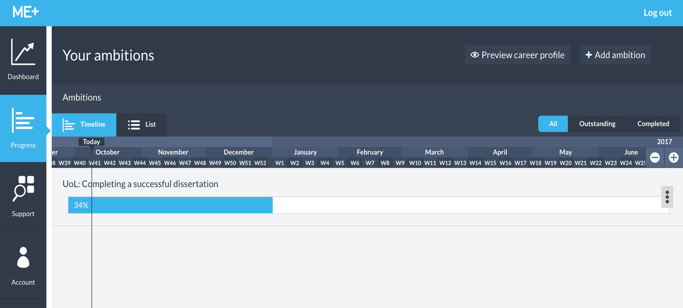

The use of gantt chart will help me stick to my plans and deliver the project on time. Below you will see a detailed schedule alongside the gantt chart for Semester 1.  
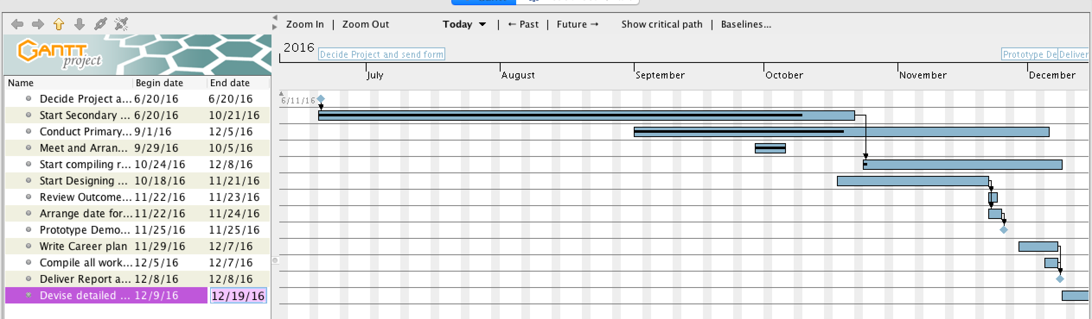  
**Time Line Semester 1:**

* Decide on project by 20/06/2016.  
  This is a milestone due to the importance. This is the start of a year long project.
* Send off project form on 20/06/2016.
* Can start conducting secondary research until 21st October 2016.  
  This research will include company reports and statistics from gyms and businesses.
* Conduct primary and qualitative research from 1st September 2016 until 5th December 2016.  
  This will include questionnaires and small focus groups.
* Both research will take place over the course of semester 1. This will help the understanding and development of the application.
* Arrange meetings with Supervisor and clarify project by 5th October 2016.
* Start compiling all data from the research into a presentable format. Need to understand the findings and start taking out what will be included in the application.  
  A time frame of 5 weeks has been allocated as research will not stop until the closing of Semester 1. It is a job to do whilst research is conducted.
* Start designing and implementing a prototype from 18th October 2016. Have until 21st November 2016 to finish a prototype.
* Within this time, must develop a plan within to understand how I will produce a prototype.   
  Must conduct research on java skills to produce the application.   
  Decide on what the prototype will focus on. It may focus on working on different platforms and having the shell or just showing all the content.  
  Start to know what data will be included in the prototype, if any.
* From the 21st November, get feedback and opinions on prototype. Use this time before delivering prototype.   
  From feedback, can alter some parts of the prototype before submission.
* Prototype Demonstration from 28th November 2016 until 2nd December 2016. Arrange a day for it.  
  Must do this in advance.  
  This is a milestone due to the importance. When this has been reached, a substantial amount of the project has been done and I can use this to reflect on my achievements but also my weaknesses. Either keep up the good work or work harder to ensure the desired grade is achieved.
* Write career plan and write up all the work done so far from 1st December till 7th December.  
  This should be simple. Keep a diary of all the work done and can put all the files together.   
  Work on the formatting and make sure it is presentable.
* If possible, meet up with supervisor between 1st December 2016 and 7th December 2016 to discuss how project will help career plan.  
  Understand how your project will develop you as an individual.  
  Keep in mind that it must be to a standard where a random person would understand the project.
* Deliver Report and Career Plan on 8th December 2016.  
  This is a milestone due to the importance. This is the last piece of work handed in before the Christmas break. From this stage I must know what is required to complete the project and what to work on over the holiday.
* Once report has been delivered, focus on constructing a detailed plan for Semester 2.
* For the whole project and work conducted, must keep in mind that a 2nd marker with no former knowledge of my goals will read this. Think about how to present it so it is easy to understand.

**Time Line Semester 2:**

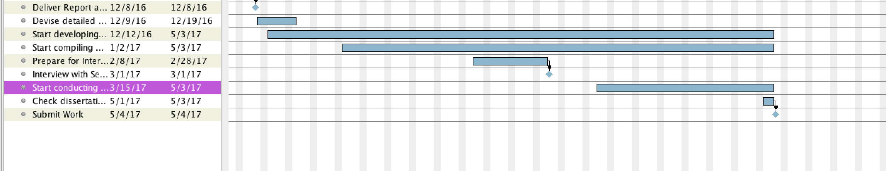

* Develop from the prototype. Start producing the final application.  
  Must have clear views on what the application does and what it will contain. Research should have concluded by now.  
  This can start from December.
* Start compiling the dissertation from 1st January 2017. Include all required areas such as Abstract, Introduction, Survey of Information Sources, Requirements, Specification and Design, Implementation and Testing, Critical Appraisal, Conclusion and finish it off with Bibliography/Citations.  
  The early start date will ensure keeping on top of this.
* Prepare for the interview from the start of February.   
  Must arrange date with second marker.  
  Take the prototype feedback into account when preparing.  
  Conduct some tests before the meeting.
* Interview with Second Marker from 27th February 2016 – 3rd March 2016.  
  This is a milestone due to the importance.
* Testing Application from April.   
  Can start testing areas that are complete to avoid a large sum of testing at the end.
* Ensure Dissertation and Application are at the correct standard. Proof read and double check before submission.
* Dissertation due 4th May.
* Application/Software System due 4th May.
* Viva and Presentation is during examination period.  
  Must prepare for this!

**The link between research and application:**

The research will aim to analyse the the rise of expenditure on gym memberships and supplements to aid a portable personal trainer application. By finding the indicators on why there has been a rise, it can help change this application from just teaching exercises, to an application that is packed with useful information and data that will help the user. For example, this application will show the types of products people use and what is preferred and why. This will help users make decisions.

The research will help me answer why there has been a dramatic rise in figures on the expenditure but also aid the development of the application. By finding out why there has been a rise, I can develop an application based on the findings to make it something a consumer desires. Hopefully this will make the application a success.

The application will contain most of the data generated from the research. This will show users more information and explain that everything is important for a healthier life, not just exercising. This application will require the research to be successful as it is being developed based on consumer behaviour and wants.

**Useful Information:**

**Timetable Semester 1:**

Project Deadlines:

* Term 1: 26th September – 9th December
* Plan: 20th October
* Proto-type Demo 3%: 28th November – 2nd December
* Interim Report and Career Plan 7%: 8th December

**Timetable Semester 2:**

Project Deadlines:

* Term 2: 9th January – 24th March
* Interview with Second Marker 5%: 27th February – 3rd March
* Term 3: 1st May – 23rd June
* Dissertation 25%: 4th May
* Software System 15%: 4th May
* Viva with Presentation 10%: During examination period.

**Section Percentages:**

* Plan: 0%
* Proto-type Demo: 3%
* Interim Report and Career Plan: 7%
* Interview with Second Marker: 5%
* Dissertation: 25%
* Software System: 15%
* Viva with Presentation: 10%
* Technical Achievements: 30%
* Effort: 5%